**MATCHMENTOR: AN APP THAT HELPS YOU FIND A TUTOR**

Presented to the Faculty of the College of Computer

and Information Science

In Partial Fulfillment of the Academic Requirements for the Subject

CS152: Human Computer Interaction

By:

Nallos, Hezron A.

Submitted To:

Cherry B. Lisondra

CCIS Faculty

June 2024

**PART I: UNDERSTANDING THE PROBLEM**

**Overview:**

In today’s fast-paced educational environment, students often struggle to find adequate academic support, particularly in subjects they find challenging. Many students face difficulties understanding course materials, leading to poor academic performance and increased stress. This problem is made worse by the limited availability of personalized tutoring services and the difficulties students face in identifying qualified tutors who can address their specific learning needs.

A lack of accessible tutoring options can create significant barriers to academic success. Students may feel overwhelmed and isolated, unable to seek help in a timely and effective manner. This can result in lower grades, reduced confidence, and a negative overall school experience. Additionally, without a reliable way to find and connect with tutors, students may spend excessive time searching for help, further detracting from their study time and academic focus.

**Solving the Problem:**

To address these challenges, the team proposes the development of a comprehensive solution named “MatchMentor.” This platform aims to connect students with qualified tutors in various subjects, providing personalized academic support and enhancing the overall learning experience. MatchMentor leverages technology to create a seamless, user-friendly platform where students can easily find and schedule tutoring sessions, ensuring they receive the help they need when they need it.

To ensure the platform meets students' needs, the team will survey 20 respondents, with 5 students from each major department: Mathematics, Science, Humanities, and Engineering. This ensures fair representation. The survey will ask about pre-planned features and their usefulness. Based on the feedback, the team will refine these features and create a prototype that aligns with student preferences, ensuring MatchMentor effectively addresses the challenges faced by the student community.

**The Application:**

**Application Name:** MM (MatchMentor)

**What the Application is:**

MatchMentor is an application being developed by Ron, a dedicated team of first-year Bachelor of Science in Information System students. Recognizing the challenges students face with accessing academic support, MatchMentor aims to bridge the gap between students and qualified tutors, empowering students to achieve their academic goals. The name MatchMentor emphasizes the primary goal of the platform, connecting students with tutors. It highlights the platform's function of creating meaningful connections between students seeking help and tutors offering their expertise, fostering a supportive and collaborative academic environment.

**Features:**

**Find Tutors:** MatchMentor provides a searchable database of qualified tutors across various subjects. Students can filter tutors based on expertise, availability, and reviews, ensuring they find the right match for their needs.

**Book Sessions:** The app offers an easy-to-use scheduling system, allowing students to book tutoring sessions at convenient times. This flexibility ensures students can receive help without disrupting their study schedules.

**Access Resources:** MatchMentor offers a curated list of academic resources, including study guides, practice exercises, and online tutorials. These resources complement tutoring sessions and provide additional support for students.

**Rate and Review:** After each session, students can rate and review their tutors. This feedback system helps maintain high-quality tutoring services and assists other students in making informed choices.

**Messaging System:** The platform includes a messaging system for students and tutors to communicate directly. This feature facilitates easy clarification of doubts and ensures smooth coordination for upcoming sessions.

**Overall Benefits:** By addressing the issues of limited access to academic support, MatchMentor aims to create a more supportive and effective learning environment for students. With easy access to qualified tutors, a flexible scheduling system, and comprehensive academic resources, MatchMentor empowers students to succeed academically and reduce the stress associated with challenging subjects.

**Questions about the Application:**

***Who are the potential users?***

The potential users of the MatchMentor platform are students from various academic disciplines who seek personalized tutoring support. Whether they are struggling with specific subjects or aiming to enhance their understanding of course materials, MatchMentor provides a unified platform tailored to their needs.

**What tasks do they seek to perform?**

The platform encourages students to find and connect with qualified tutors, schedule tutoring sessions, and access additional academic resources to support their learning.

**What functionality should any system provide to these users?**

The platform’s main function is to provide a user-friendly interface for students to search for tutors, book sessions, access study materials, and communicate with tutors efficiently.

**What constraints will be placed on your eventual design?**

Although MatchMentor does not require proof of enrollment at a specific institution, the platform is primarily intended for studentsseeking academic support. Outsiders can still access the website but are encouraged to keep topics related to academic tutoring.

**What criteria should be used to judge if your design is a success or not?**

The team’s program should be able to successfully pass the following criteria:

* The user should be able to navigate the platform with ease and little to no struggle.
* The user should find it convenient and effective to book tutoring sessions.
* The user should have access to high-quality tutoring services and academic resources.
* The user should experience improved academic performance and reduced stress as a result of using the platform.

**Approach:**

**PART II: DESIGNING ALTERNATIVES**

**Project Description**

The project aims to develop an interactive platform to enhance student engagement and support within educational institutions. The platform will facilitate communication between students and faculty, provide access to academic resources, and offer personalized support services. The intended user population includes high school and college students, teachers, and academic advisors.

**Requirements Summary**

* User Authentication: Secure login for students and faculty.
* Communication Tools: Chat and video call features.
* Resource Access: Centralized repository for academic resources.
* Personalized Support: AI-driven personalized academic advising.
* Feedback Mechanism: Tools for gathering and analyzing student feedback.

**Design Space**

The design space of potential interfaces for our system encompasses a wide range of possibilities, reflecting different approaches to solving the problem of enhancing student engagement and support. This section explores various dimensions of the design space, including the complexity of requirements, trade-offs, and task support.

**What requirements may be difficult to realize?**

**AI-Driven Personalized Support:**

Implementing advanced AI algorithms to provide personalized academic advice tailored to individual students' needs is a significant challenge. This requires sophisticated data analysis, machine learning models, and ensuring data privacy and security.

**Seamless Communication Tools:**

Developing robust and reliable real-time communication tools that can handle high traffic and ensure smooth user experience across different devices can be technically complex.

**Offline Access:**

Enabling offline access to resources and support features in a mobile app requires sophisticated data synchronization mechanisms and local storage solutions, which add complexity to the design and development process.

**What are some tradeoffs that you should or did explore?**

* **Complexity vs. User-Friendliness:**
  + Balancing rich features with ease of use is crucial. Adding more features can enhance functionality but may make the interface more complicated and harder to navigate. Conversely, simplifying the interface may improve usability but at the cost of reduced functionality.
* **Performance vs. Aesthetics:**
  + High-quality graphics and animations can make the interface visually appealing but may affect performance, especially on lower-end devices. We need to find a balance between a visually appealing design and maintaining fast, responsive performance.
* **Integration vs. Standalone Features:**
  + Integrating the platform with existing tools and systems like LMS and social media can enhance usability but may introduce dependencies and complexities in maintaining compatibility. A standalone approach simplifies development but may limit the platform's overall functionality.

**Which tasks will be easiest to support? Which are the hardest?**

**Easiest Tasks to Support:**

* **User Authentication:**
  + Implementing secure login mechanisms using widely accepted practices like OAuth or single sign-on.
* **Resource Access:** 
  + Providing a centralized repository for academic resources with straightforward navigation and search capabilities.
* **Feedback Mechanism:** 
  + Creating tools for gathering and analyzing student feedback through surveys and polls is relatively simple using existing frameworks.

**Hardest Tasks to Support:**

* **AI-Driven Personalized Support:** 
  + Developing and maintaining advanced AI models that provide accurate and useful advice tailored to individual students' academic progress.
* **Real-Time Communication Tools:** 
  + Ensuring reliable, high-quality real-time communication (chat, video calls) that works seamlessly across different devices and network conditions.
* **Data Synchronization for Offline Access:** 
  + Implementing efficient and reliable data synchronization mechanisms to ensure that users can access and update information offline and sync changes when reconnected.

This exploration of the design space helps us understand the scope of possibilities and constraints, guiding us in developing diverse and innovative design alternatives that address the core problem effectively.

**Design Summary**

* **Alternative 1:** Mobile App Focus
  + Not pursued
    - Limited screen space for detailed resources.
* **Alternative 2:** System-based Platform
  + Pursued
    - More screen real estate and easier integration with other web tools.
* **Alternative 3:** Hybrid Approach
  + Pursued
    - Combines the flexibility of system platforms with the accessibility of mobile apps.

**The Designs**

**Design 1:** System-based Platform

**Overview:**

A web-based platform providing centralized access to resources, communication tools, and personalized support.

**GUI Illustrations:**

**

**Storyboard:**

**User Perspective Scene:**

Jane, a college student, logs into the platform, checks her messages from her advisor, and accesses her course materials.

**Assessment:**

* Advantages:
  + Easy access, robust features.
* Disadvantages:
  + Requires internet connectivity.
* User Feedback:
  + Positive feedback on the layout and ease of use. Concerns about internet dependency.

**Design 2:** Mobile App

**Overview:**

A mobile app designed for on-the-go access to communication and support tools.

**Assessment:**

* Advantages:
  + Portability, instant notifications.
* Disadvantages:
  + Limited screen space.
* User Feedback:
  + Users appreciated the portability; some found the navigation challenging on smaller screens.

**Design 3:** Hybrid Approach

**Overview:**

A hybrid approach combining web and mobile interfaces for flexibility.

Assessment:

* Advantages
  + Flexibility, cross-platform continuity.
* Disadvantages
  + Requires synchronization.
* User Feedback
  + Positive feedback on the flexibility but some technical issues with synchronization.

**Requirements Changes**

* Changes:
  + Added requirement for offline access in the mobile app.
* Reason:
  + Feedback from users about internet dependency.

**PART III: SYSTEM PROTOTYPE AND EVALUATION**

**Project Description:**

MatchMentor is an innovative web-based application developed by Team RON, designed to bridge the gap between students and qualified tutors across various subjects. The application provides a seamless platform where students can easily search for, connect with, and schedule sessions with tutors who meet their specific academic needs. By offering features like a user-friendly interface, detailed tutor profiles, and integrated scheduling and messaging systems, MatchMentor aims to enhance the learning experience, foster academic growth, and ensure students receive the personalized support they need to succeed in their studies.

**Requirements Summary:**

|  |  |  |
| --- | --- | --- |
| **MINIMUM REQUIREMENTS** | Processor Cores | Dual Core |
| OS | Windows 7 / macOS 10.10 (Yosemite) / Linux |
| RAM | 4 GB |
| **RECOMMENDED REQUIREMENTS** | Processor Cores | Quad Core |
| OS | Windows 10 / macOS 10.14 (Mojave) / Linux |
| RAM | 8 GB |
| **OTHER REQUIREMENTS** | Permissions | Internet Access, Notifications, Storage |

Table 1. System Requirements

To cater to low-end desktop models, the application will have at most a minimum of 2 Cores, 4 GB worth of RAM, and desktop versions windows 7 / macOS 10.10 (Yosemite) / Linux as its OS. The app itself is not at all demanding, hence our team has settled on lower requirement specs.

**Prototype Description:**

The Prototype was created with the use of Figma. This is because Figma is an interactive Prototyping Software/Website that can easily be distributed to testers with the use of links sent by the developers.

**SASHA Figma Link**:

<https://www.figma.com/proto/6IPVVVqojpJqyhG8jPWJgP/MatchMentor-Prototype?node-id=602-1134&t=0WMQici3z7ErHky9-1&scaling=scale-down&content-scaling=fixed&page-id=1669%3A162202>

**User Scenario:**

Tanjiro and Nezuko have been struggling to keep up with their coursework due to a lack of personalized academic support. This issue is affecting their overall school performance. They have difficulty finding reliable tutors and managing their study schedules, leading to poor grades and stress.

One day, Tanjiro discovers an app called MatchMentor, recommended by one of his friends who is excelling in his studies. He installs the app and starts to explore its features. He notices that MatchMentor allows students to easily connect with qualified tutors, schedule tutoring sessions, and track their academic progress. Seeing how this app could address their current problems, Tanjiro shares it with Nezuko. Together, they begin using MatchMentor to find the right tutors and stay on top of their studies, improving their performance and reducing their acade

**MatchMentor Mock-up/Prototype:**

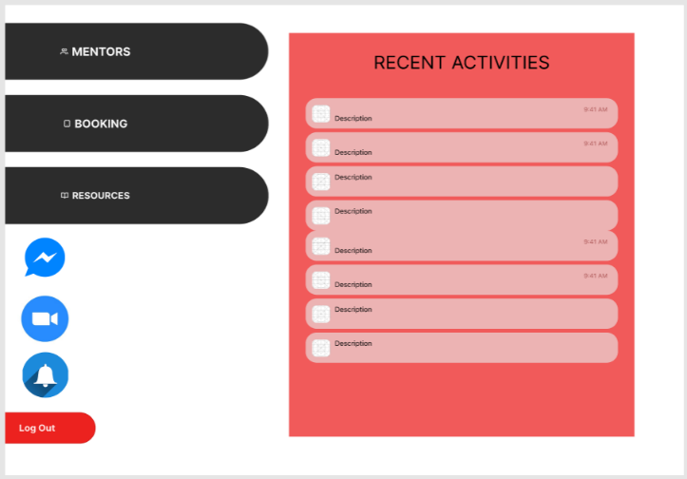

**Student Home Page**

The student home page is where the student user can access the mentor list, bookings, resources, messages, zoom meeting, and notifications.

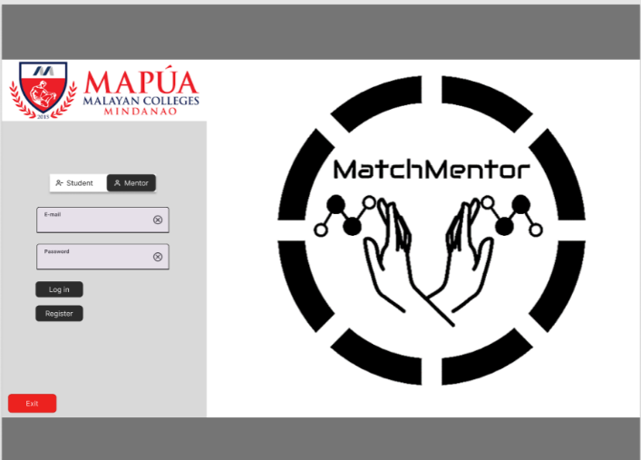

**Log In Page**

The log in Page is where a user can register or log in as a student or a mentor. It has the system logo

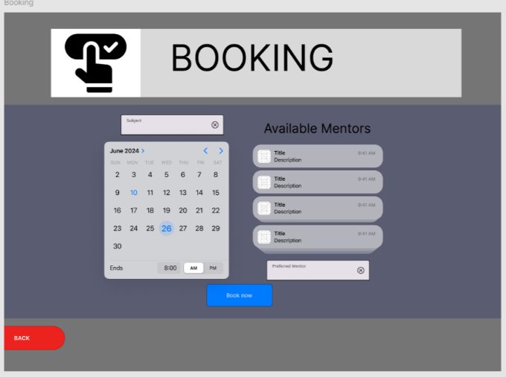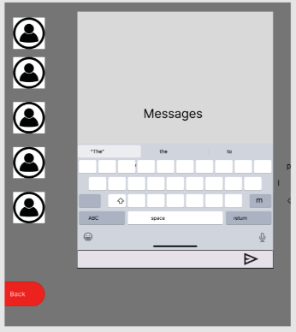

**Booking Page**

The Booking page is where the student user can book the time, date, and the specific subject that the student wants a mentor in.

**Messages Page**

The messages page is where students and mentors can communicate easily.

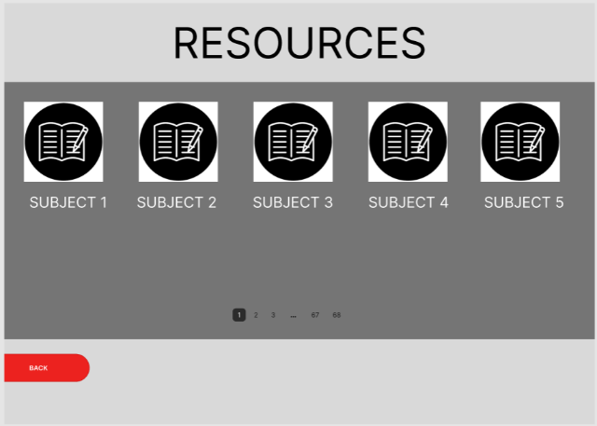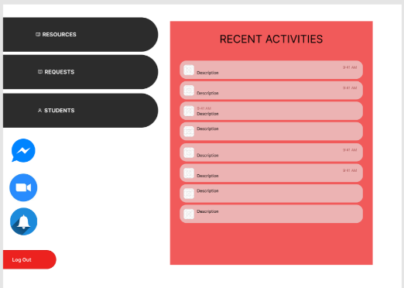

**Resources Page**

The resource page is where students can access learning materials.

**Mentor Home Page**

The mentor home page is where mentors can access their resources, booking requests, and their students. As well as the messages, zoom meetings, and the notifications.

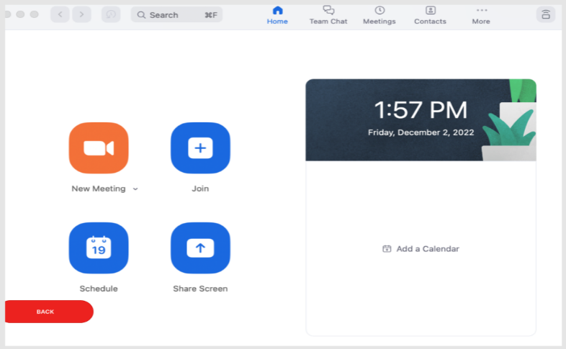

**Zoom Meeting Page**

The zoom meeting page is where the students and mentors can access zoom and its features.

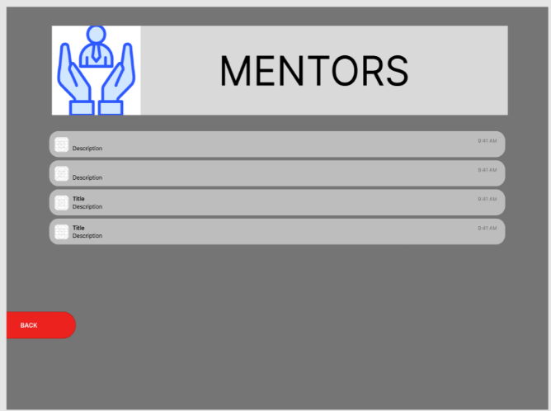

**Mentor List Page**

The Mentor page is the list of the mentors available.

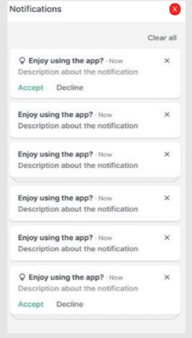

**Notifications Page**

The notifications page is where the students and mentors can be notified.

**Prototype Flow:**

Figure 1 shows how the user uses the app to book a mentor.

**

The student first log ins to access the home page.

Sets the schedule, inputs subject, and chooses mentor.

Presses the Booking Button to open the Booking Page.

This is where the student can see the notifications.

This is the mentors (POV) where he/she will receive a request that the student has booked.

Once the mentor has accepted the request, the student will receive a notification that the mentor has accepted for tutoring.

Here is where the student and mentor will meet in the specified schedule.

**Figure 1**

**Rationale:**

The team has chosen to use Figma for creating the MatchMentor prototype because it is a free, interactive platform that both team members can access to edit the prototype collaboratively. Figma facilitates the showcasing of the final design of the application, making it convenient for presenting and sharing prototypes with users who are not physically present. It also allows for easy modifications based on feedback. However, Figma does require internet access for saving edits, which can be a limitation if the user does not have a stable connection. Additionally, on larger screens, smaller buttons might be challenging to interact with.

**Changes to the Requirements:**

No specific changes were made to the system requirements; however, several changes were made in the usability criteria for the prototype. These revisions aimed to address the question, “How easy can a user use this prototype?”. The revised criteria are based on the 10 Usability Heuristics, which include Minimalist Design, Recognition, Flexibility, Freedom, and Consistency, among others. Furthermore, due to time constraints, the implementation of certain online features was discarded, and thus, the criteria for these features were removed. The primary goal is to keep the prototype as straightforward and user-friendly as possible to avoid confusing users when they transition to the complete version of the prototype.

**Initial Evaluation Plan:**

Due to the ongoing quarantine and remote learning circumstances, the team cannot conduct the evaluation through traditional means. Instead, alternatives like Microsoft Teams and Discord will be used to ensure the team can observe live interactions with the prototype.

The evaluation plan is divided into three parts: Usability Specifications, Heuristics Evaluation, and Participant Survey and Feedback.

**Usability Specifications:**

The creation of this prototype aims to achieve the following measures:

* + **Effectiveness:** Evaluates how well the prototype performs the required tasks.
  + **Efficiency:** Assesses how easy and straightforward the prototype is to use.
  + **Utility:** Ensures the prototype supports appropriate functions and alternatives for certain tasks.
  + **Learnability:** Measures how easy it is for users to learn to use the prototype system.
  + **Memorability:** Assesses how easily users can remember the steps for using the system.

**Heuristic Evaluation:**

The MatchMentor prototype will be evaluated using the 10 Usability Heuristics method:

* + **Visibility of System Status:** The prototype keeps users informed about what is happening.
  + **Match Between System and Real World:** The prototype uses familiar language and follows real-world conventions.
  + **User Control and Freedom:** The prototype provides "Emergency Exit" options to leave unwanted states easily.
  + **Consistency and Standards:** Ensures consistency in the prototype's language and actions.
  + **Error Prevention:** Carefully designed to prevent problems from occurring.
  + **Recognition Rather Than Recall:** Makes objects, actions, and options visible, reducing the user's memory load.
  + **Flexibility and Efficiency of Use:** Caters to both experienced and inexperienced users, allowing them to tailor frequent actions.
  + **Aesthetic and Minimalist Design:** Avoids irrelevant information, focusing on what is necessary.
  + **Help Users Recognize, Diagnose, and Recover from Errors:** Uses plain language for error messages and suggests constructive solutions.
  + **Help** **and** **Documentation**: Provides easily accessible help and documentation.

**Participant Survey and Feedback:**

After conducting the online test, the team will gather data through:

* + **Survey (Quantitative):** Participants will rate their experience with the prototype using a 5-point Likert scale.
  + **Feedback (Qualitative):** Participants will provide detailed feedback on their experience, highlighting any concerns or issues.

These methods will ensure that the prototype meets the usability criteria and is well-received by the target users.

**Project Description**

MatchMentor is a web-based platform designed to enhance student engagement and support by connecting students with qualified mentors. The system facilitates the booking of mentoring sessions, communication between students and mentors, and access to learning resources. MatchMentor aims to improve students' academic performance by offering personalized tutoring in various subjects. The platform targets students seeking academic assistance and mentors who are experts in their respective fields.

**Requirements Summary:**

|  |  |  |
| --- | --- | --- |
| **MINIMUM REQUIREMENTS** | Processor Cores | Dual Core |
| OS | Windows 7 / macOS 10.10 (Yosemite) / Linux |
| RAM | 4 GB |
| **RECOMMENDED REQUIREMENTS** | Processor Cores | Quad Core |
| OS | Windows 10 / macOS 10.14 (Mojave) / Linux |
| RAM | 8 GB |
| **OTHER REQUIREMENTS** | Permissions | Internet Access, Notifications, Storage |

Table 1. System Requirements

To cater to low-end desktop models, the application will have at most a minimum of 2 Cores, 4 GB worth of RAM, and desktop versions windows 7 / macOS 10.10 (Yosemite) / Linux as its OS. The app itself is not at all demanding, hence our team has settled on lower requirement specs.

**Overview**

The evaluation plan comprises three parts: Usability Specifications, Heuristics Evaluation, and Participant Survey and Feedback. These methods were chosen to assess usability, adherence to design principles, and gather user perspectives effectively given current remote learning conditions.

**Techniques and Tasks**

**Usability Specifications**

Tasks:

Evaluate effectiveness, efficiency, utility, learnability, and memorability.

Rationale:

These tasks were selected to assess how well users perform essential actions and navigate through the prototype. Effectiveness measures the accuracy and completeness of tasks, efficiency evaluates the resources expended, utility assesses the relevance of the system features, learnability gauges how easy it is for new users to accomplish tasks, and memorability examines how easily users can remember how to use the system over time. These criteria collectively provide a comprehensive view of usability and user experience.

**Heuristics Evaluation**

Principles:

Visibility of System Status, Match Between System and Real World, User Control and Freedom, Consistency and Standards, Error Prevention, Recognition Rather Than Recall, Flexibility and Efficiency of Use, Aesthetic and Minimalist Design, Help Users Recognize, Diagnose, and Recover from Errors, Help and Documentation.

Rationale:

The selected usability heuristics provide a structured approach to identifying design strengths and weaknesses based on established principles. Each heuristic addresses common usability issues that can significantly impact user experience. By applying these heuristics, we can systematically evaluate the interface design against recognized usability standards and guidelines, helping to uncover potential usability problems early in the design process.

**Participant Survey and Feedback**

Survey:

Quantitative ratings on usability, UI design, task ease, and qualitative feedback on user experience.

Rationale:

Surveys and qualitative feedback provide subjective insights from users, complementing objective usability metrics obtained from other evaluation methods. Quantitative ratings allow for the measurement of user perceptions on specific aspects such as usability, interface design, and task complexity. Qualitative feedback offers deeper insights into user preferences, satisfaction levels, and areas needing improvement, helping to prioritize design changes based on user priorities and experiences.

These methodologies collectively ensure a comprehensive evaluation of the MatchMentor platform, combining objective performance metrics with subjective user perceptions to drive iterative improvements and enhance overall usability and user satisfaction.

**Technique 1: Usability Specifications**

**Data Presentation:**

* + Effectiveness: 83% of tasks were successfully completed by users.
  + Efficiency: Users took an average of 4.5 minutes to complete tasks, indicating moderate efficiency.
  + Utility: Features received an average rating of 4.2 out of 5 for relevance and usefulness.
  + Learnability: New users took approximately 8 minutes on average to accomplish basic tasks.
  + Memorability: 75% of returning users remembered how to use the system.

**Data Analysis:**

* + Effectiveness: High success rates suggest generally intuitive task flows and clear instructions. However, lower completion rates in specific tasks highlight areas of confusion or inadequate feedback.
  + Efficiency: The moderate efficiency indicates manageable task complexity, but longer completion times in some tasks suggest potential for streamlining.
  + Utility: Positive ratings indicate that most features align well with user needs, though there are suggestions for enhancing some features based on user feedback.
  + Learnability: The average time for new users indicates a reasonable learning curve, though improvements in onboarding and initial guidance could reduce this time.
  + Memorability: High retention rates indicate a user-friendly design overall, but some users may benefit from clearer design cues or help features.

**Design Implications:**

* + Adjustments Needed: Address issues with unclear instructions in specific tasks and simplify complex task flows to improve overall usability.
  + Improvements: Simplify interface elements, enhance feedback mechanisms to provide clearer guidance, and refine feature relevance based on user feedback to optimize usability.
  + Major Flaws: Identified usability issues suggest the need for fundamental redesigns in navigation and layout to enhance user experience comprehensively.

**Technique 2: Heuristics Evaluation**

**Data Presentation:**

* Visibility of System Status: Generally met, but inconsistencies noted in updating user actions.
* Match Between System and Real World: Partially met, with terminology discrepancies causing confusion.
* User Control and Freedom: Mostly met, but issues found in undoing actions.
* Consistency and Standards: Largely met, with minor deviations in button placement.
* Error Prevention: Partially met, with some error-prone areas identified.
* Recognition Rather Than Recall: Generally met, though some menu options required recall.
* Flexibility and Efficiency of Use: Partially met, with advanced features not easily discoverable.
* Aesthetic and Minimalist Design: Mostly met, but visual clutter noted in certain sections.
* Help Users Recognize, Diagnose, and Recover from Errors: Partially met, with error messages needing clearer guidance.
* Help and Documentation: Generally met, but navigation within help sections could be improved.

**Data Analysis:**

* Identified violations of heuristics such as inconsistent system status updates and terminology discrepancies impacting user understanding and control. Prioritized issues based on severity, focusing on critical areas affecting usability frequently.

**Design Implications:**

* Address heuristic violations through interface adjustments to enhance system status visibility, standardize terminology, and improve error prevention mechanisms. Consider redesigns where heuristics are consistently violated to ensure adherence to usability principles and improve overall user experience.

**Technique 3: Participant Survey and Feedback**

**Data Presentation:**

* Quantitative Ratings: Usability received an average rating of 4.3 out of 5, UI design 4.1, and task ease 4.2.
* Qualitative Feedback: Common themes include requests for streamlined navigation, clearer instructions in complex tasks, and enhanced mobile responsiveness.

**Data Analysis:**

* Analyzed trends indicating strong satisfaction with overall usability and UI design, with specific suggestions for improving task clarity and responsiveness. Feedback was compared against initial usability goals and requirements to prioritize actionable improvements.

**Design Implications:**

* Prioritize changes based on user feedback, focusing on enhancing navigation simplicity, refining task instructions, and improving mobile interface responsiveness. Implement improvements to address user concerns and enhance overall satisfaction, ensuring alignment with user expectations and usability goals.

This comprehensive evaluation provided valuable insights into the MatchMentor platform's strengths and areas for enhancement, guiding iterative design improvements to optimize usability and user satisfaction in remote learning contexts.

**Critique and Summary**

The usability evaluation of the MatchMentor platform utilized three main methodologies which are, Usability Specifications, Heuristics Evaluation, and Participant Survey and Feedback to comprehensively assess its functionality, adherence to design principles, and user perspectives in remote learning contexts. This approach aimed to provide a thorough understanding of user interaction effectiveness and usability perceptions.

Advantages included the structured application of usability heuristics, facilitating early identification of design flaws, and the integration of user-centered feedback, which prioritized both subjective experiences and objective metrics. Challenges such as managing diverse qualitative feedback interpretations and the resource-intensive nature of evaluations were acknowledged.

The evaluation revealed strengths in task effectiveness and various usability principles, suggesting intuitive design elements conducive to effective user interaction and learning experiences. Areas for improvement included enhancing task efficiency and improving interface consistency to better align with initial design objectives.

Overall, the evaluation emphasized the iterative process of design refinement, highlighting the ongoing importance of user feedback and adherence to usability standards in developing a more intuitive and effective learning tool for MatchMentor users. This approach not only guides immediate enhancements but also lays the groundwork for continuous improvement based on evolving educational needs and user expectations.